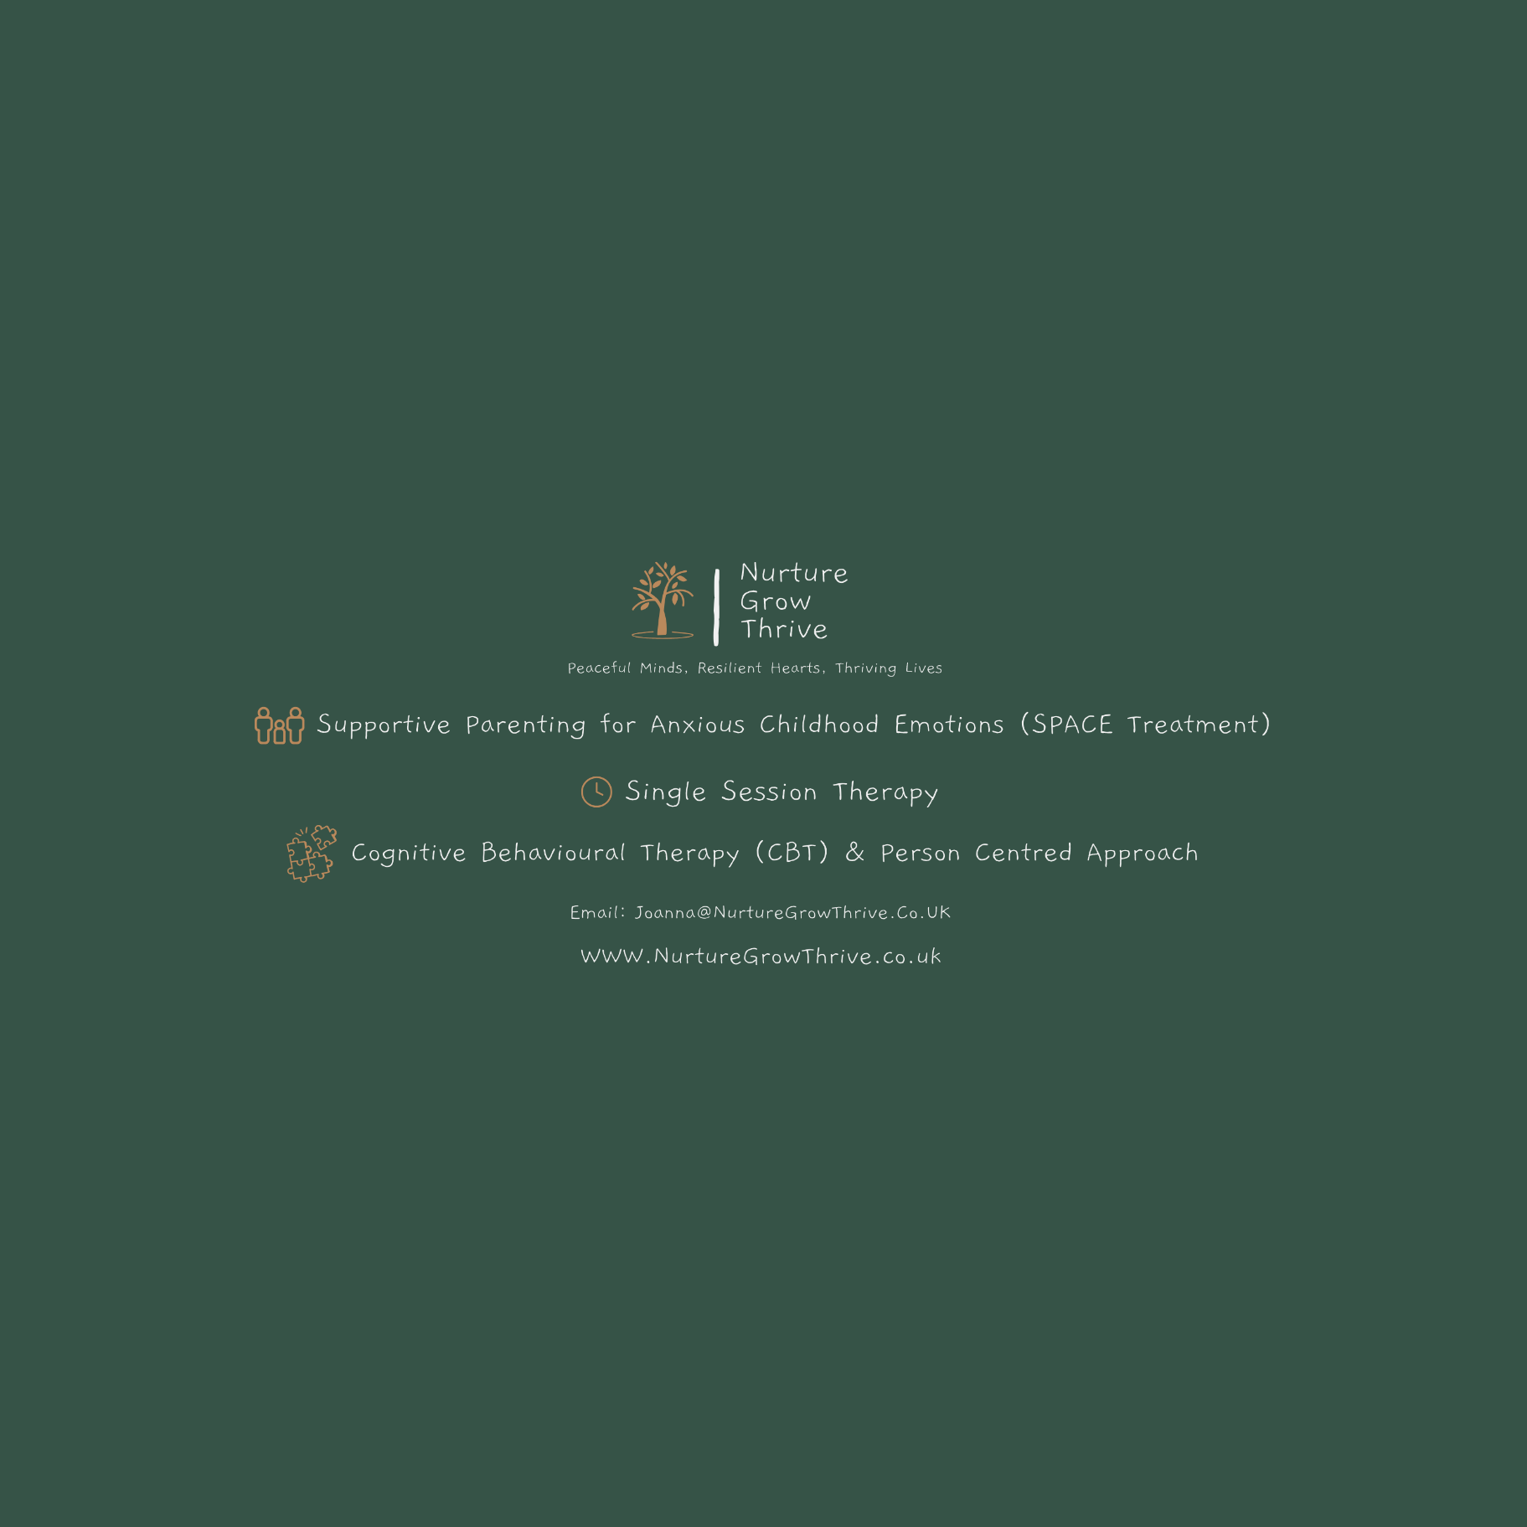
Safeguarding Policy and Procedure for Joanna Griffin – Nurture Grow Thrive
Introduction
This policy outlines the safeguarding procedures for Joanna Griffin – Nurture Grow Thrive. It covers the safeguarding of both children and adults, in accordance with UK legislation and professional guidelines, including those set forth by the British Association for Counselling and Psychotherapy (BACP).
Purpose
The purpose of this policy is to:
- Protect children, young people, and adults at risk who receive counselling services from this practice.
- Ensure that this practice operates in accordance with the law and best practice guidelines in relation to safeguarding.
Legal Framework
This policy has been drawn up on the basis of UK law and guidance that seeks to protect children and vulnerable adults
Definitions
- Child: Anyone under the age of 18 years.
- Adult at risk: Any person aged 18 who may be in need of support to protect themselves against significant harm or exploitation.
Safeguarding Commitment
- The welfare of the child or adult at risk is paramount.
- All children and adults at risk, regardless of age, disability, gender, racial heritage, religious belief, sexual orientation or identity, have the right to equal protection from all types of harm or abuse.
- Working in partnership with children, adults at risk, their parents, carers and other agencies is essential in promoting their welfare.
Safeguarding Procedures
Prevention
- Commitment to regular safeguarding training updates.
Responding to Concerns
- Suspected or disclosed abuse will be responded to sensitively within the session along with discussing next steps and reporting. Safeguarding concerns are an exception to confidentiality (please see contract)
- I reserve the right to break confidentiality if I think that you have become a danger to yourself or other people. I will attempt to discuss this with you and my supervisor first, but this may not always be possible.
- I am not bound by confidentiality if in good faith I feel that I can assist in the prevention or detection of a serious crime, this includes safeguarding issues regarding children or vulnerable adults, crimes regarding substantial financial gains and losses, and acts of terrorism.

Reporting routes to ensure safety
- Emergency – Police 999 / 101 non-emergency
- GP – details on client record
- Parents of under 18 if appropriate
- NSPCC Helpline on 0808 800 5000
- Local authority Social Care services https://www.nhs.uk/service-search/other-health-services/local-authority-adult-social-care

Record Keeping
- All safeguarding concerns, discussions, and decisions made, and the reasons for those decisions, will be recorded in writing.
- Records will be stored securely and confidentially, in compliance with GDPR and data protection regulations.
- I hold an enhanced DBS check registered with the update service.

Confidentiality and Information Sharing
- Client confidentiality is of utmost importance but will never override the need to protect a child or adult at risk from harm.
- Information will be shared on a 'need-to-know' basis only.
Online Safety
- Session conducted over Zoom through Power Diary (Zanda) Clinic Management Software to ensure online counselling sessions are secure and private.

Supervision
- Engagement in regular clinical supervision to discuss cases and safeguarding concerns.
Review
This policy will be reviewed annually or sooner if there are significant changes in legislation or best practice guidelines.
Date of last review: [15/10/24] Next review due: [15/10/25]
Signed: Joanna Griffin - Counsellor and Practice Owner

