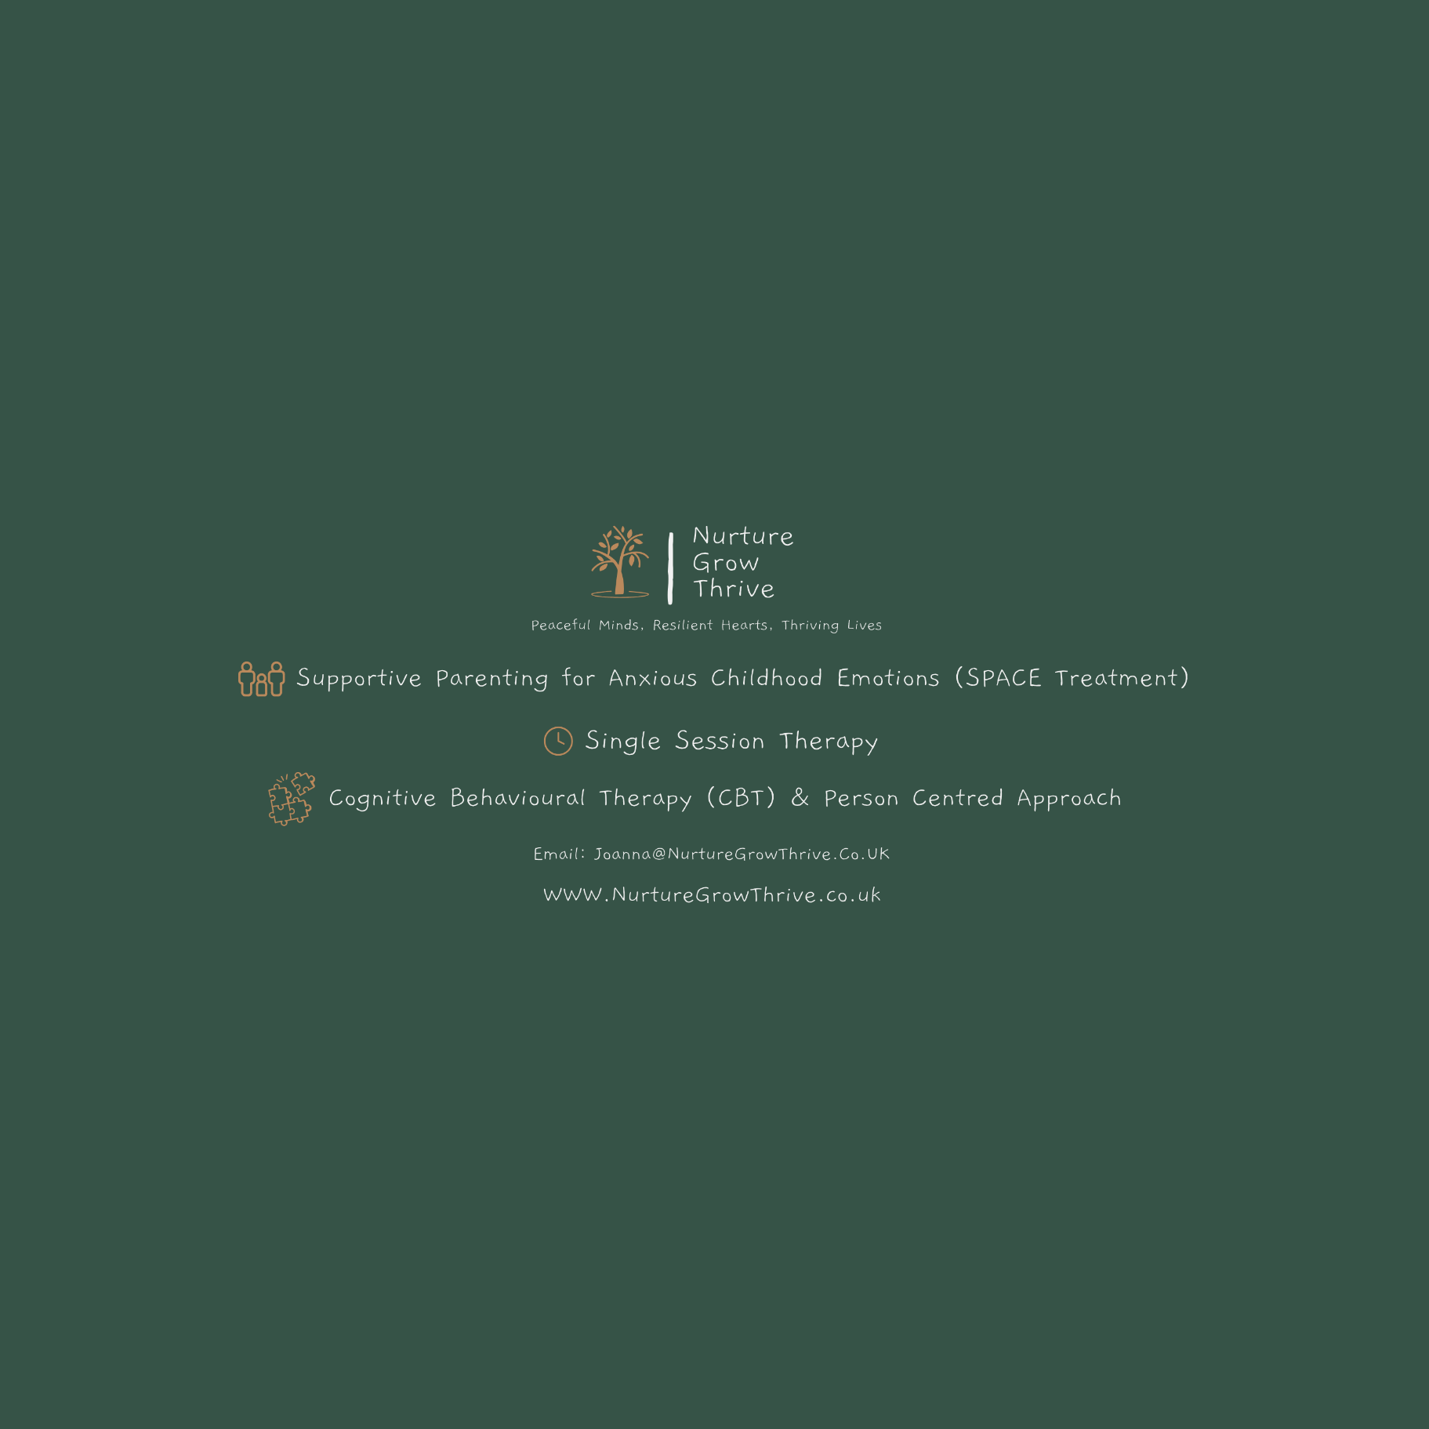
Counselling Contract
Please read the information below carefully as it forms an agreement as to how we will work together and outlines my professional obligations regarding confidentiality. At our first session I will set some time aside for us to discuss this agreement and answer any queries that you may have. In the meantime, I will ask you to sign the agreement to show that you understand its contents.
I am a registered member of the British Association for Counselling and Psychotherapy (BACP) and as such abide by their ethical framework.
Please see - http://www.bacp.co.uk/ethical-framework for more information.
Anti-discriminatory practice
I am committed to providing an anti-discriminatory service. I strive to ensure this practice is present in all our work together.
The way that I work
There are a variety of approaches to the way practitioners work with their clients. I have been trained in the therapeutic approaches of person centred counselling and cognitive behavioural therapy (CBT) and utilise these within a series of sessions or within a single session model as per your preference and our agreement. I have further undertaken additional training to offer SPACE (supportive parenting for anxious childhood emotions) treatment.
The person centred approach aims to provide a safe, non-judgmental space where you are truly heard and valued. Rooted in empathy and compassion, this approach empowers you to explore your feelings at your own pace, fostering personal growth and self-discovery.
Cognitive Behavioural Therapy (CBT) is a practical, goal-oriented approach that helps you identify and change unhelpful thinking patterns and behaviours. By focusing on the here and now, CBT equips you with tools to manage challenges and create lasting positive changes in your life.
Single session therapy offers a chance to experience therapy using a combination of approaches without any long-term commitment.
SPACE is a revolutionary program from America scientifically proven to reduce anxiety in children without the child needing to engage in therapy.
​Please see https://www.bacp.co.uk/about-therapy/types-of-therapy/ for more information on different therapeutic approaches and WWW.nurturegrowthrive.co.uk for more information on my own work.
​ I only offer appointments online via Zoom – (through Power Diary -Zanda- Clinic Software).

Duration, termination and missed sessions
​We will discuss the planned duration of our work together during the initial session and review your progress during each session. In terminating longer term counselling, it is recommended to meet for a final closing session to address any unresolved issues and finish in a safe manner.
Excepting an emergency situation, I will provide you with 7 days notice if I am unable to provide a session. Please advise me at your earliest opportunity if you are unable to attend a booked session. Cancellation with less than 24 hours notice will be charged at full session price. For clients receiving consecutive sessions I will be unable to guarantee the same time slot if more than 2 sessions are missed without advance notice.
If you arrive late unfortunately I will not be able to extend the session, as this will affect my other appointments.
Whilst the aim of counselling is to work with you through your difficulties, and to help you to develop new ways of coping, some people find that they feel worse for a short time before they start to feel better or that therapy is not effective for them. In these circumstances it is best to discuss the difficulties, rather than abruptly end counselling, in order to have the chance to discuss the decision and to complete the process adequately. You are always in charge of the decision to continue or to stop counselling and will not be under any pressure to continue at any point.
Contact between sessions​
I am only able to see you by prior appointment.
If you require my professional services between sessions I can be contacted during normal working hours by email. I will endeavour to reply as soon as possible.
If you are unable to wait for me to reply, or require emergency or urgent professional assistance please contact NHS Direct on 111, your GP, the emergency services or Samaritans on freephone 116123 or online at https://www.samaritans.org/how-we-can-help/contact-samaritan/
Fees
I charge a fee of £55 for each 50 minute therapy session. This is payable on booking to ensure reservation of your session time.
If my fees increase I will provide you with 6 weeks notice.
You can pay via the payment link which will be sent by email or by bank transfer.
Supervision
All members of BACP are required to have regular supervision. My work continues to be supervised to ensure that it is safe, ethical and effective. Aspects of our work may be discussed during these sessions, but no full name will be used, and identifiable details removed. My supervisor is a member of BACP and as such they are bound by the same confidentiality rules as myself. In keeping with the requirements of BACP’s Ethical Framework I have appointed a trusted colleague to take over the administration of my practice in the event of my death or incapacity, and to deal with my appointments and destroy my notes in a confidential manner. This colleague is also a member of BACP and is bound by the same professional confidentiality rules as set out in their Ethical Framework.
Counselling on-line
I use Zoom through Power Diary (Zanda) Clinic Management software for appointments and in the event either of us suffers technical difficulties I will contact you on the telephone number you have provided to continue our session.
Confidentiality
As a member of BACP I am bound by their Ethical Framework to protect a client’s confidentiality. Therefore, everything that we discuss is confidential except in certain circumstances, which are listed below.
Exceptions to confidentiality:
Harm to self or others
I reserve the right to break confidentiality if I think that you have become a danger to yourself or other people. I will attempt to discuss this with you and my supervisor first, but this may not always be possible.
For legal and ethical reasons
I am not bound by confidentiality if, in good faith, I feel that I can assist in the prevention or detection of a serious crime, this includes safeguarding issues regarding children or vulnerable adults, crimes regarding substantial financial gains and losses, and acts of terrorism.
Emergency contact.
If, during a session, I become concerned for your immediate welfare I will contact the named contact you have provided. I will endeavour to discuss this with you first. I will not discuss any of our work together with this contact, other than to request they contact you to ensure your welfare.
Record keeping confidentiality
As a member of BACP I am required to keep accurate and appropriate notes of our work together. I record my session notes securely and am registered with the Information Commissioner’s Office (ZB753017). Any information that I keep is subject to the Data Protection Act 2018 and United Kingdom General Data Protection Regulation UK-GDPR see Information Commissioner’s Office: https://ico.org.uk and BACP’s Privacy notice. https://www.bacp.co.uk/privacy-notice.
Complaint
If there is anything that you do not understand about this agreement, or if you would prefer it in a different format, please let me know. Similarly, if you are not happy with any of our sessions or the standard of my work, I hope that you would feel able to talk to me about this. If you feel unable to talk to me or in the event of a serious complaint, please contact the BACP ‘Get help with counselling concerns’ service which provides confidential telephone and email guidance on what to do if you have concerns about your therapy or therapist. Phone 01455 883300 or email gethelp@bacp.co.uk, or write to BACP, 15 St John’s Business Park, Lutterworth LE17 4HB.

