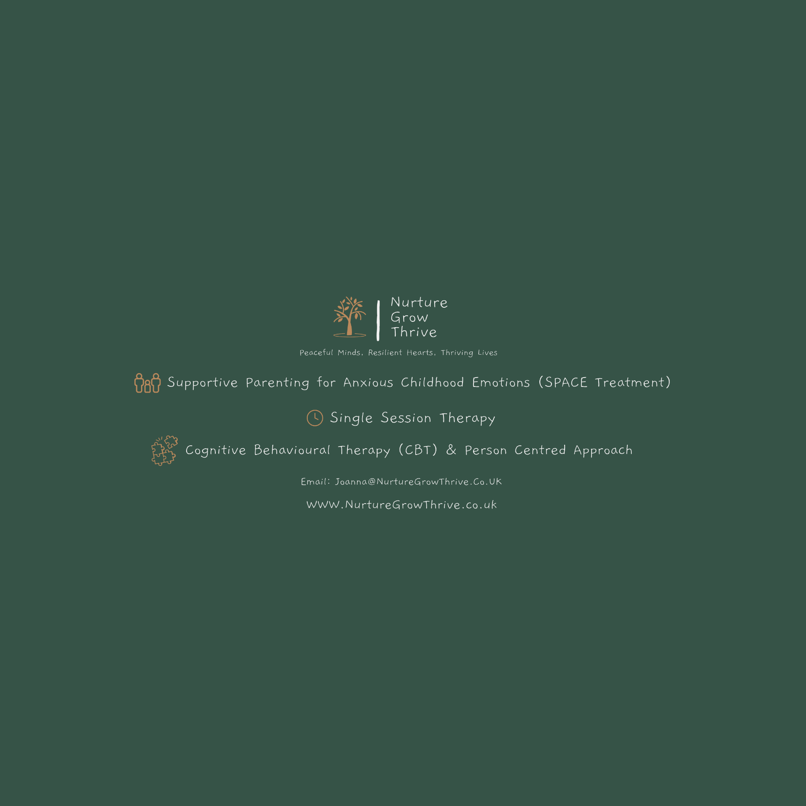
GDPR and Data Processing Policy
Introduction
Your privacy is very important to me and you can be confident that your personal information will be kept safe and secure and will only be used for the purpose it was given to me. I adhere to current data protection legislation, including the General Data Protection Regulation (EU/2016/679) (the GDPR), the Data Protection Act 2018 and the Privacy and Electronic Communications (EC Directive) Regulations 2003. This privacy notice tells you what I will do with your personal information from initial point of contact through to after your therapy has ended.
I am happy to talk through any questions you might have about my data protection policy, and you can contact me via joanna@nurturegrowthrive.co.uk.
‘Data controller’ is the term used to describe the person/ organisation that collects and stores and has responsibility for people’s personal data. In this instance, the data controller is me. I am registered with the Information Commissioner’s Office (ZB753017).
My lawful basis for holding and using your personal information
The GDPR states that I must have a lawful basis for processing your personal data. There are different lawful bases depending on the stage at which I am processing your data:
- If you have had therapy with me and it has now ended, I will use legitimate interest and insurance company conditions as my lawful basis for holding and using your personal information.
- If you are currently having therapy or if you are in contact with me to consider therapy, I will process your personal data where it is necessary for the performance of our contract.

The GDPR also makes sure that I look after any sensitive personal information that you may disclose to me appropriately. This type of information is called ‘special category personal information’. The lawful basis for me processing any special categories of personal information is that it is for provision of health treatment (in this case counselling) and necessary for a contract with a health professional (in this case, a contract between me and you).
How I use your information - Initial contact.
When you contact me with an enquiry about my counselling services I will collect information to help me satisfy your enquiry. If you decide not to proceed I will ensure all your personal data is deleted immediately.

While you are accessing counselling.
Rest assured that everything you discuss with me is confidential. That confidentiality will only be broken if I think that you have become a danger to yourself or other people. I am not bound by confidentiality if in good faith I feel that I can assist in the prevention or detection of a serious crime, this includes safeguarding issues regarding children or vulnerable adults, crimes regarding substantial financial gains and losses, and acts of terrorism. I will always try to speak to you about this first, unless there are safeguarding issues that prevent this.
I will keep a record of your personal details to help the counselling services run smoothly. These details are kept securely on Power Diary (Zanda) Clinic Software. Once counselling has ended your records will be kept for 5 years as per insurance company requirements (5 years after turning 18 for under 18’s) from the end of our contact with each other and are then securely destroyed. If you want me to delete your information sooner than this, please tell me.
Third party recipients of personal data.
Your data will be stored on Power Diary (Zanda) Clinic Software and Microsoft Office which have been carefully selected to ensure your data is safe and encrypted and can only be accessed by me for its intended purpose.
I try to be as open as I can be in terms of giving people access to their personal information. You have a right to ask me to delete your personal information, to limit how I use your personal information, or to stop processing your personal information. You also have a right to ask for a copy of any information that I hold about you and to object to the use of your personal data in some circumstances. You can read more about your rights at ico.org.uk/your-data-matters.
If I do hold information about you I can:
• give you a description of it and where it came from
• tell you why I am holding its, tell you how long I will store your data and how I made this decision
• tell you who it could be disclosed to
• let you have a copy of the information in an intelligible form.
You can also ask me at any time to correct any mistakes there may be in the personal information I hold about you. To make a request for any personal information I may hold about you, please put the request in writing to joanna@nurturegrowthrive.co.uk.
If you have any complaint about how I handle your personal data please do not hesitate to get in touch with me by writing or emailing to the contact details given above. If you want to make a formal complaint about the way I have processed your personal information you can contact the ICO which is the statutory body that oversees data protection law in the UK. For more information go to ico.org.uk/make-a-complaint.
I take the security of the data I hold about you very seriously and as such I take every effort to make sure it is kept secure by using encryption and password protection.
When someone visits my website, I use a third party service, Wix to collect standard internet log information and details of visitor behaviour patterns. I do this to find out things such as the number of visitors to the various parts of the site. This information is only processed in a way that does not identify anyone. I do not make, and do not allow Wix to make, any attempt to find out the identities of those visiting my website. I use legitimate interests as my lawful basis for holding and using your personal information in this way when you visit my website. I use Wix so that I can continually improve my service to you. No user-specific data is collected by me or any third party. If you fill in a form on my website, that data will be temporarily stored on the web host before being sent to me.
Date of last review: [15/10/24] Next review due: [15/10/25]
Signed: Joanna Griffin - Counsellor and Practice Owner

